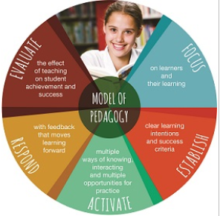**Planning for inclusion of Catholic Social Teaching using   
BCE Model of Pedagogy**

**Unit Title/ Topic: ________________________________**

**Year Level: _______________**

|  |  |  |
| --- | --- | --- |
| **Focus** | | |
| **Who are my Learners? What prior knowledge do they have on content and CST on this topic?** |  | |
| **Focus Australian Curriculum Content Descriptors** |  | |
| **Which Catholic Social Teaching Principles links to this content?** |  | |
| **How could these CST be explored through this content?** |  | |
| **Establish** | | |
| **Learning Intentions** |  | |
| **Success Criteria** |  | |
| **Activate** | | |
| **Lesson ideas to teach CST through content** | **Activities** | **Resources** |
|  |  |
| **Opportunity for “See, Judge, Act” project** |  | |
| **Respond** | | |
| **Opportunities for Feedback (formative and summative) to students and from students about the learning** |  | |
| **Evaluate** | | |
| **What are ways to improve this unit or learning experience?** |  | |